**Ideation Phase**

**Define the Problem Statements**

|  |  |
| --- | --- |
| Date | 27 June 2025 |
| Team ID | LTVIP2025TMID59564 |
| Project Name | Edututor AI: personalized learning with generative AI and lms integration |
| Maximum Marks | 2 Marks |

**Customer Problem Statement:**

Many college students preparing for exams often face the challenge of quickly grasping lengthy and complex academic content. They aim to revise and understand topics efficiently, but the material they encounter is often too dense and time-consuming to go through manually. This issue is further intensified by the limited time available for revision, especially during exam season. As a result, students feel overwhelmed and anxious, struggling to find effective tools that can simplify their learning process and boost their confidence before exams.

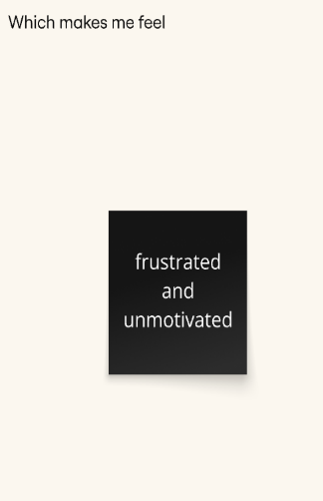

**Customer Problem Table**

|  |  |  |  |  |  |
| --- | --- | --- | --- | --- | --- |
| **Problem Statement (PS)** | **I am (Customer)** | **I’m trying to** | **But** | **Because** | **Which makes me feel** |
| **PS-1** | a college student preparing for exams | quickly understand lengthy textbook topics | the material is too long and complex | I don’t have enough time to revise everything manually | overwhelmed and anxious |
| **PS-2** | A self-learner using online content | test myself with short quizzes | most platforms require login or payment | I just want a fast and simple way to practice instantly | frustrated and unmotivated |